Deploying Amazon RDS Multi-AZ and Read Replica, Simulate Failover

Step 1: Creating EC2 Linux instance

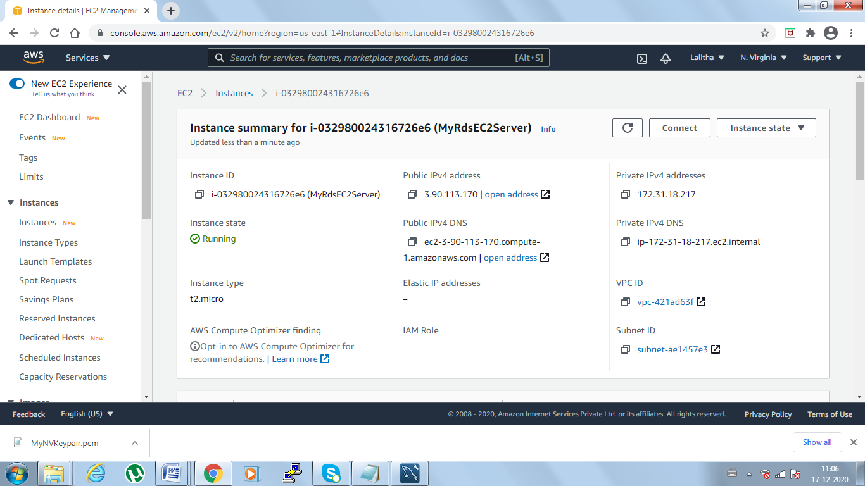

Step2: While creating the RDS select the multi AZ Deployment

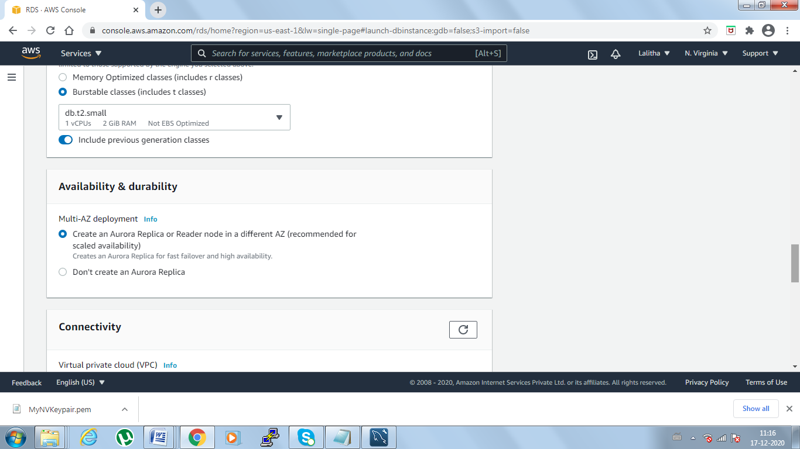

Step3: DB Cluster created with Write (Master) and Reader(failover)

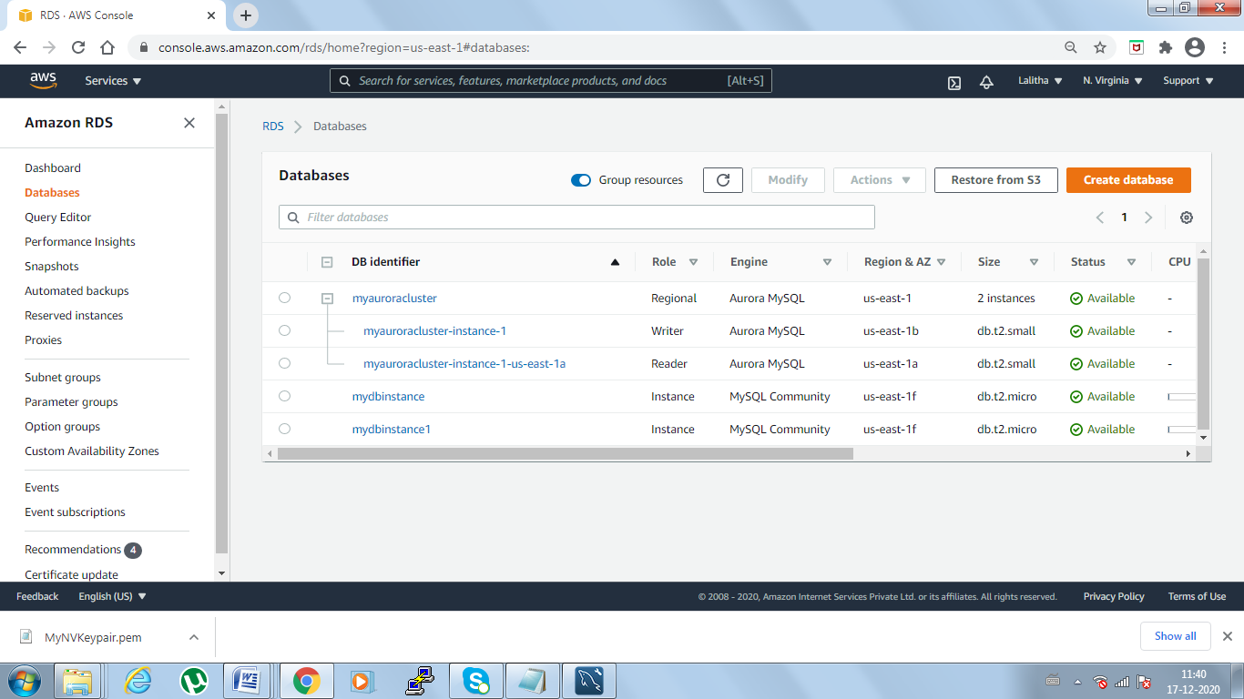

Step 4: Editing the Inbound rules by adding the private IP of EC2 instance

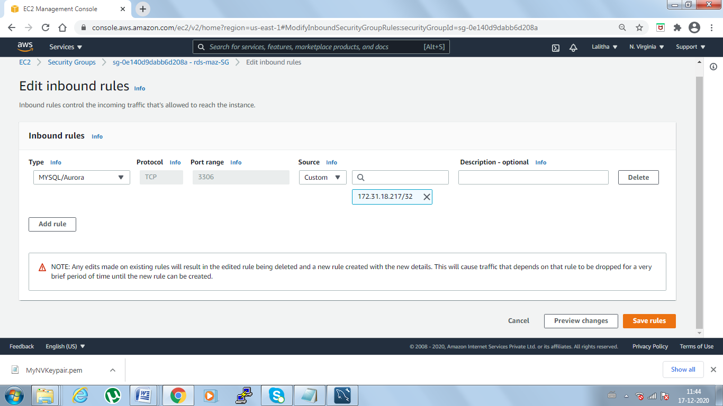

Step5: Connecting to SSH with Writer Endpoint and creating the DB and tables

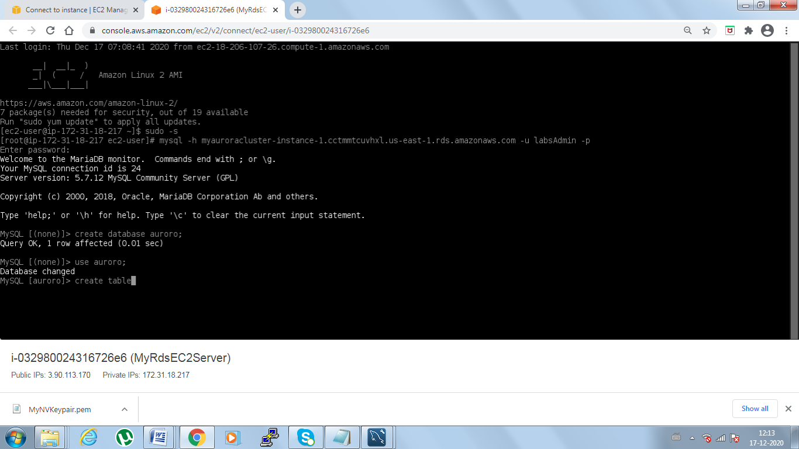

Step6: Entering the data into tables

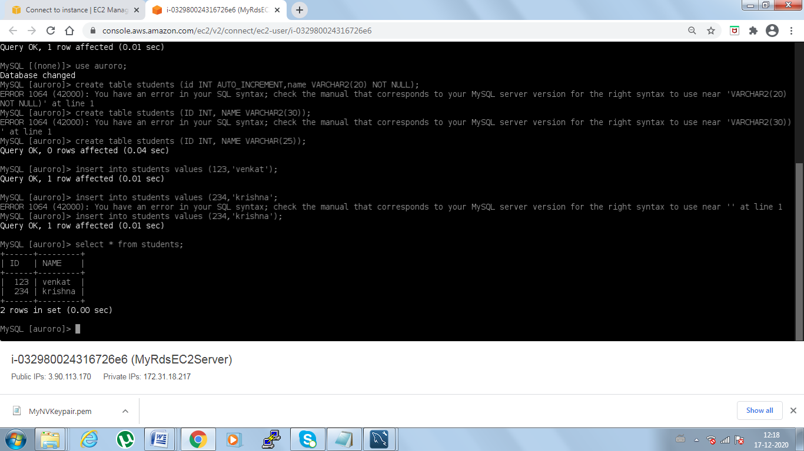

Step7: Failover test so that Writer becomes Reader and Reader becomes Writer

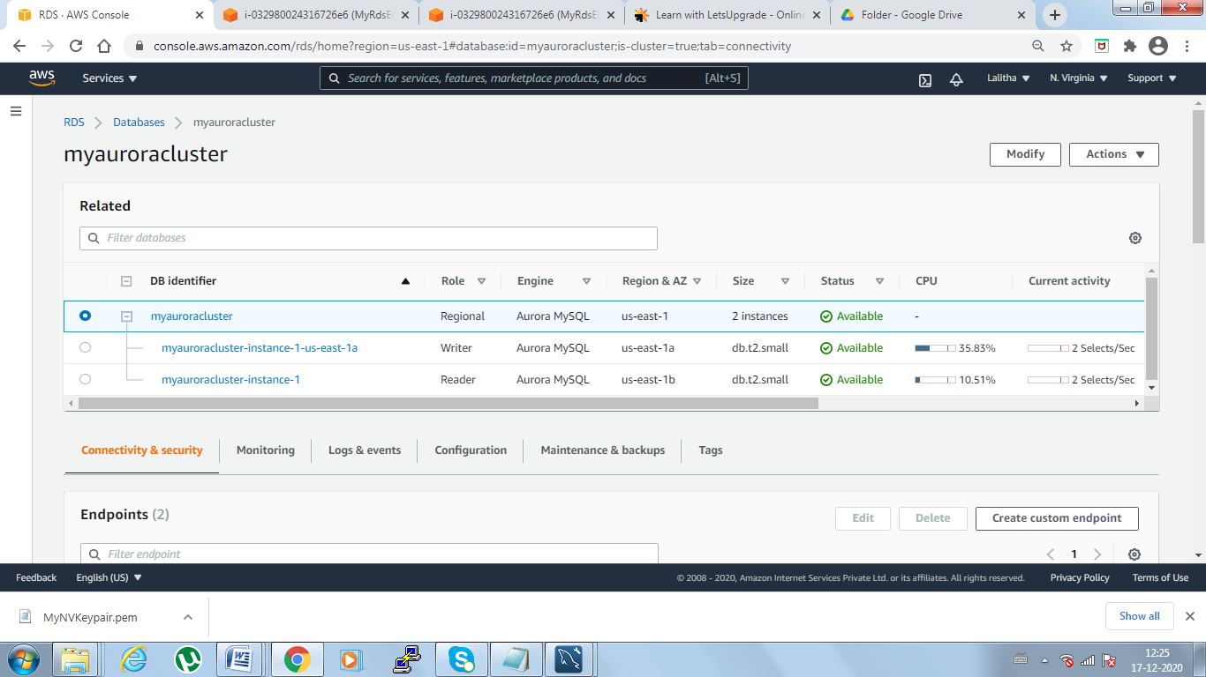

Step8: Connecting to Failover instance and trying to fetch the DB tables and data

